Red foxes' impact on Dasyurid population
INTRODUCTION:
An ecosystem common to much of Australia is the arid/semi-arid grassland ecosystem (Davis, 2013). This ecosystem is characterised by open flat land, with few large trees or obvious water sources, and is populated mainly by grasses and small shrubs and trees. This ecosystem is so common in Australia because of the wide spread dry climate in much of inland Australia (Suttle et al; 2005). The vegetation is adapted to low water levels with deep roots and tough foliage designed to not lose water. Animals species are also adapted to this ecosystem and are generally smaller, often nocturnal, and there are very few large predators because of this.
The most important abiotic factor influencing this ecosystem is low water availability as rainfall is typically less than 500mm per year. (Suttle et al; 2005). Another important abiotic factor is the lack of nutritional content in the soil. The combination of low rainfall and poor soil is the main reason that grasses and shrubs (and not large trees) are the most common vegetation present.
Almost all of the animal species in this ecosystem rely on the grasses and shrubs as a source of food and as a source of habitat. Species in the ecosystem include insects, reptiles, birds, mammals, and Dasyurids (marsupial mammals) – which are all native to Australia. The introduced species include as rabbits and red foxes. There are two types of biotic relationships which are very important in arid grassland ecosystems. The first is competition, and many native animal avoid competing with each other for food (as it is scarce), so they have developed highly specialised feeding behaviours to avoid competition. The second common biotic relationship is predator prey relationships. There are very few large carnivores in arid ecosystems, and the carnivores present tend to eat only specific species and not a whole range of prey animals. This is typical of an ecosystem where animals are avoiding having to compete with each other for prey.
The introduction of the red fox into the arid/semi-arid grassland has had a significant impact on the populations of native animal species. Foxes eat the introduced rabbit species, but foxes have a very diverse diet and have been shown to lower the populations of small native mammals in several Australian ecosystems (Green and Osbourne, 1981; Christensen, 1980). Despite arid/semi-arid grasslands covers two-thirds of Australia, the impact of ed foxes on this ecosystem has not yet been directly measured, and can only be assumed to be consistent with the impact they have had on other ecosystems.

Research Question
To what extent are native marsupial mammals (dasyurids) comparable to rabbits as a prey species for introduced red foxes in arid grassland ecosystems.

The Data
The data used in this investigation was obtained from "The ecology of the introduced red fox in the arid zone". This paper was published in 1992, and authored by Nicole Marlow, a PhD student at the university of NSW. The research was conducted in an arid grassland region of north west NSW. The research was conducted in an arid grassland region of north west NSW. The research investigated the distribution of prey species within the red fox diet.
The prey of the fox were identified by scat (faecal, “pooh”) analysis. In the data below rabbits were used as a comparison value for Dasyurids. The number of scats with rabbit remains was compared to the number of scats with Dasyurid remains
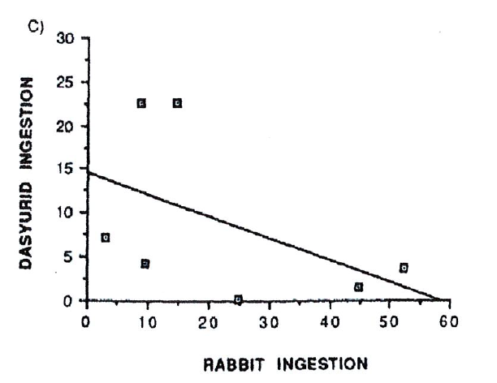
Data Analysis
Rabbits appeared to be consumed more often that dasyurids by the red fox. Rabbit remains were identified in every collection of scats, with a max of 52 scats in one of the collections, and in a total of 159 scats. Dasyurids remains were not found in the scats in every collection (zero was recorded once), a max of 23 scats was the highest in any of the collections, and in a total of 63 scats. Foxes therefore appear to eat rabbits in greater numbers than native dasyurids.
Dasyurid remains in the scat appears highest when rabbit remains in the scat are low. The highest number of dasyurid remains found (23) was twice found when the number of rabbit remains was only 10 and 15. The lowest number of dasyurid remains (0, 2, and 4) was found when rabbit remains were high (25, 45, and 52). This suggests that when the foxes eat rabbits they do not eat dasyurids, and that foxes eat dasyurids when they do not eat rabbits.

Conclusion
The preferred prey species of the red fox is rabbits and not Dasyurids. Rabbit remains were approximately 2.5 times more likely to be found in the scat of red foxes than dasyurids. This suggests that dasyurids, compared to rabbits were eaten far less, and less consistently.
Red foxes switch to hunting dasyurids when rabbit population is low. When rabbit remains were less common in the scat of the red fox, Dasyurids remains were found more often, and vice versa. This suggests that dasyurids are a secondary prey species of the red fox and are hunted only when there are not many rabbits available.
References
Too lazy to do these!!!! – but you had better!

